Easter Island and the Moai Kavakava

Easter Island or Rapanui, so named by Dutch explorer Jacob Roggeveen, who encountered it on Easter Sunday 1722, is the most isolated inhabited island on Earth, with its closest inhabited neighbor, Pitcairn Island, 2,075 km (1,289 mi) to the west. When the first settlers arrived from Nuku Hiva between 300 CE and 800 CE under the legendary leader Hotu Matu'a, they landed at Anakena Beach and subdivided the island into Ahu Pua'a or pie-shaped slices extending from the coast to the volcanic peaks to assure that each group of settlers would have access to all resources, from the sea to the mountains. Initially, it was a paradise, but it was unexpectedly fragile.

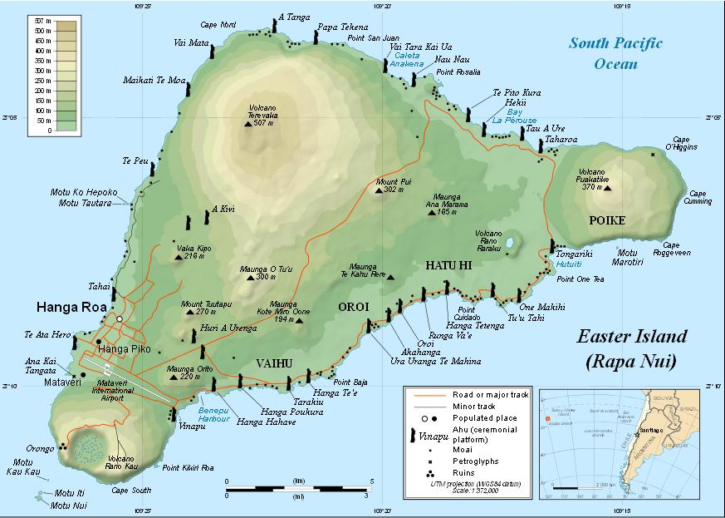Able to flourish during the ensuing period that roughly corresponds to the Neoatlantic Altithermal period (800-1200 CE) the island succumbed to the onset of a climatic downturn during the Pacific Climatic Period when the growing season began to shorten and the rainfall lessened around 1250-1300 CE.

Easter Islanders thought this was due to their own transgressions against the gods, so they began to carve large stone statues from volcanic basalt and rolled these statues down to seaside platforms where they erected them as offerings to the ancestors, whom they believed they had in some way wronged with their actions.

Although the sculpting of these 887 statues or *Moai* (as they are called in Rapanui, the language of Easter Island) was difficult, the transportation of them to the seaside was disasterous as they needed coconut trees to roll them down the steep volcanic slopes. Some were placed facing seaward, while others were placed facing inland to watch over the people.

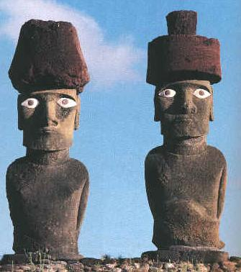 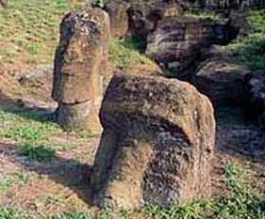

The destruction of the coconut trees spelled the end of their once paradisal life, for once the last trees were cut there was no more wood for building rafts or boats and the people were emprisoned on their island and reduced to fishing from land. Food became scarce and the climate continued to worsen. In northern Europe this climatic downturn was known as the Little Ice Age. The *Moai* had forsaken the people. Tribal wars ensued and the *Moai* were toppled or buried.

Left: Basalt Moai reconstructed showing the visual effect of scoria pupils set in bone eyes. After http://www.crystalinks.com/moai_eyes.jpg. right Moai buried up to their shoulders. After http://www.crystalinks.com/moaiburied.jpg.

The *ali'i* or elders believed another, more effective means of atonement was required from the ancestors if they were to survive. The people had noted the seasonal migratory flight of birds over their isolated island prison. Perhaps these were the ancestors scrutinizing their activities. So a new cult was developed by the *ali'i*. This was the cult of the bird man or *Tangatu Manu* in which each year the most adept athletes were enjoined to swim from the mainland at Orongo to an offshore islet, Moto Nui, were the sooty terns would lay their eggs. Sooty terns were pelagic birds and rarely sought land except to lay their eggs and rear their young.

The islet of Moto Nui was one of the few places in the eastern Pacific where the the sooty terns alighted, and to the Easter Islanders the annual migration of the sooty terns was seen as a sign from the ancestors of their attempt to help their struggling descendants, for the eggs represented a source of food for the destitute Easter Islanders.

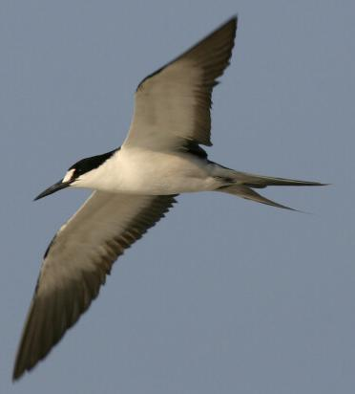

Sooty tern in flight illustrating its split tail. After http://www.outdoorcentral.com/articles/wp-content/uploads/2008/09/20080917007.jpg.

And so patriotic youths lined up to climb down the steep volcanic cliffs of Orongo, to swim across the shark infested waters to the sooty tern breeding grounds of Moto Nui and to return with the first fruits of the year--the first of the eggs of the sooty tern.

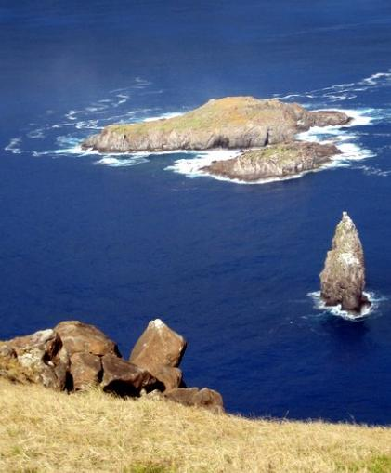

Moto Nui as seen fron Orongo. After http://upload.wikimedia.org/wikipedia/commons/2/29/Rano-Kau-2b-Birdman-Cult.JPG

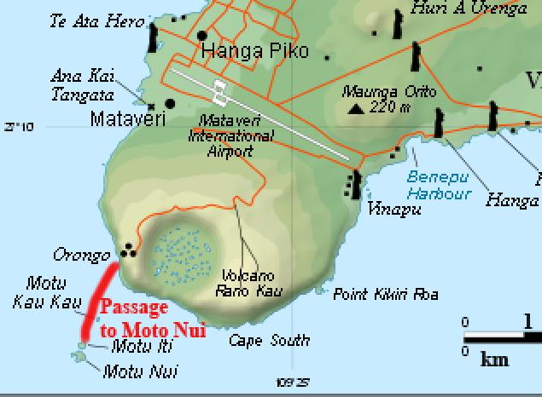

Easter Island after http://upload.wikimedia.org/wikipedia/commons/thumb/b/bc/Easter_Island_map-en.svg/250px-Easter_Island_map-en.svg.png.

These eggs became a symbol of renewal, of hope that things might get better if only the ancestors would acknowledge this effort and intercede with the forces of nature. And so the egg of the sooty tern became a symbol of new life--how ironic on "Easter" Island. Eggs were carved from driftwood with double-headed images of the sooty tern incised on them or with their egg gatherers emerging from them as new hatchlings. These eggs were called "*Tahonga.*" The two heads possibly indicated the outward journey and return from the sooty tern island. In any case the Janus-like figures reinforced the concept of looking outwardly and looking inwardly. How psychologically appropriate for the dire ecological disaster the islanders were faced with.

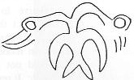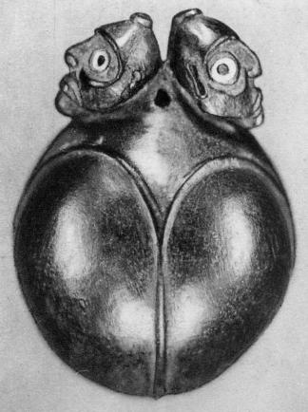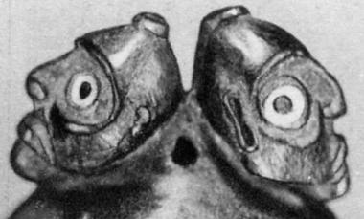

Left: bicephalic avian motif on a *Tahonga* or egg-shaped pendant in the collection of the Padri Dei Sacri Cuori, Rome (Foment 1993:207). Right: a *Tahonga* , 6 in. high, illustrating its egg-shape and dual cephalus with detail of bearded figures with shark vertebrae and obsidian eyes from *Sophora toromiro* (Chauvet 2004 [1935], Fig. 94.

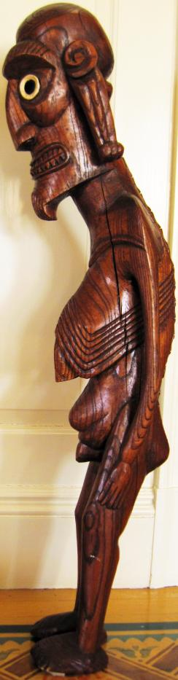

S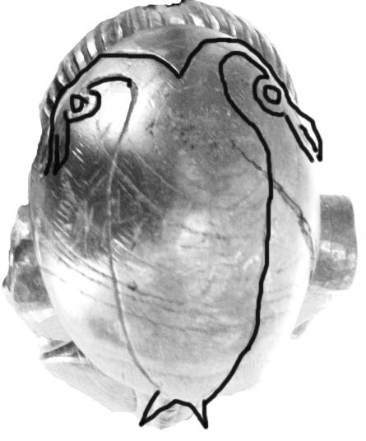ince there were no more trees to cut, another carving tradition was developed, the *Moai kavakava* or "ribbed statue" in the language of Rapanui. This time the statute was of an aged man with bald head on top of which was inscribed, perhaps as a tattoo, the same double-headed sooty tern image as was engraved on the *Tahonga*, the wooden eggs. The cranium was exaggerated, for in Polynesia the top of the head was considered the seat of spiritual power. Carved from indigenous wood of the *toromiro* hardwood, its eyes of obsidian pupils and white shark vertebrae were the symbols of a visionary, as had the peering eyes of the earlier stone *Moai*. These statues stand slightly off balance with emaciated ribs and protruding spines to accentuate their hoary age and selfless sacrifice. Elongated ears denote their elevated *ali'i* status. For these are the ancient ones who were once the champion bird-men, the *Hopu*, the ones who had risked their lives to save their people. No longer able to accomplish the feat of securing the symbolic sooty tern egg, they now stand as mute sentinels as once and future champions of their people -- a hope in the future reflecting the sacrifices they had made in their youth.

The double-headed sooty tern image on the top of the

*Moai Kavakava* head.

*Moai Kavakava*, 37 in. tall

References

CHAUVET, STEPHEN. 2004 [1935]. *Easter Island and Its Mysteries*, trans. A. M. Altman. Fig. 94, from http://www.chauvet-translation.com/index.htm.

HEYERDAHL, T. 1975. *The art of Easter Island*. New York: Doubleday, 1975.

FISCHER, S.R. (ed.). 1993. *Easter Island studies. Contributions to the history of Rapanui in memory of William T. Mulloy*. Oxford: Oxbow. Oxbow Monograph 32.

FOMENT, FRANCINA. 1993. "'You are Crab, Crayfish, and Octopus': Personal and Group Symbols in Rapanui Wood Sculpture," in Fischer (1993): 206-213.

ORLIAC, C. 1993. "Types of wood used in Rapanui carving," in Fischer (1993): 201-5.   
ORLIAC, C. & M. ORLIAC. 1995. *Bois sculptes de l'Ile de Paques*. Marseille: Editions Parentheses.